

National Textile University
Department of Computer Science
Subject: Operating System

Submitted to: Sir Nasir

Submitted by: Maha

Reg. number: 23-NTU-CS-1170
Lab 12
Semester:5th

Docker Lab 02

Data Persistence, Custom Images, Networking & Docker Compose

Quick Day 1 Recap What We Learned Yesterday
Core Concepts:
Docker solves the “It Works on My Machine” problem Images = blueprints, Containers = running instances
Containers are lightweight and fast compared to VMs Images contain OS userspace but share host kernel Essential Commands:
do
c
ker

run

#
C
re
a
te

a
nd

st
a
rt

c
ont
a
iners
do
c
ker
ps
#
L
ist

c
ont
a
iners
do
c
ker

logs

#
V
iew

c
ont
a
iner

output
do
c
ker
exe
c
#
R
un

c
omm
a
nds

in

c
ont
a
iners
Quick Check:
#
V
erify

D
o
c
ker

is

running
do
c
ker
--
version
do
c
ker
ps
If you see any errors, make sure Docker Desktop is running!

Part 1: Data Persistence with Volumes
Why This Matters:
Before building complex applications, you need to understand how to keep your data safe.
Imagine building a blog and losing all posts when you restart!

The Problem: Container Data is Ephemeral
What Happens to Data in Containers?
Let’s see what happens to data when a container stops:
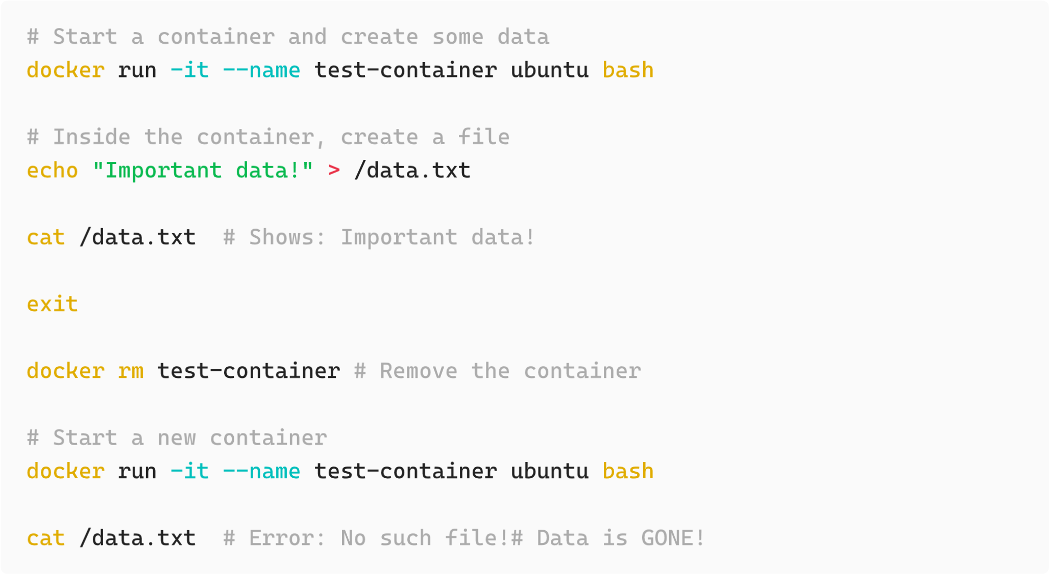
Terminal:
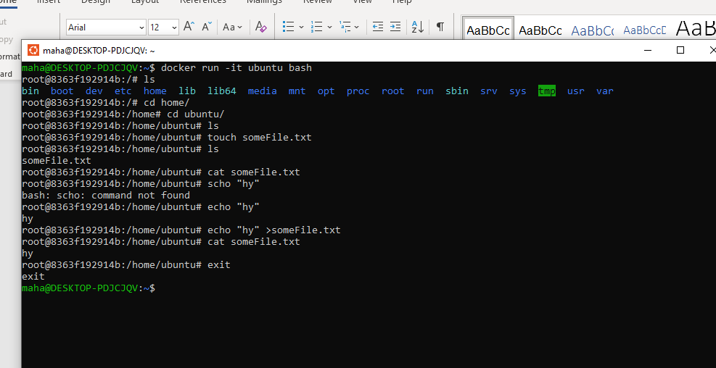
The problem:
Container filesystems are temporary
Data disappears when container is removed
Can’t share data between containers
Not suitable for databases, uploads, logs, etc.

The Solution: Docker Volumes
Volumes are Docker-managed storage that persists outside containers.
Think of volumes as:
External USB drives that you can plug into containers
Persistent storage that survives container deletion
Shareable between multiple containers

Types of Docker Storage

1. Named Volumes (Recommended for Production)
What: Docker-managed storage in a special location
Where: Docker manages the location (usually /var/lib/docker/volumes/ ) When: Databases, persistent app data, production use
#
C
re
a
te

a

n
a
med

volume
do
c
ker

volume

c
re
a
te

my
-
d
a
t
a
#
L
ist

volumes
do
c
ker

volume

ls
#
I
nspe
c
t

volume

det
a
ils
do
c
ker

volume

inspe
c
t

my
-
d
a
t
a
#
U
se

volume

in

c
ont
a
iner
do
c
ker

run

-
it
-
v

my
-
d
a
t
a
:
/
home
/
u
b
untu
/
my
-
proje
c
t

u
b
untu
#
R
emove

volume
(
only

when

not

in

use
)
do
c
ker

volume

rm

my
-
d
a
t
a
#
R
emove

a
ll

unused

volumes
do
c
ker

volume

prune
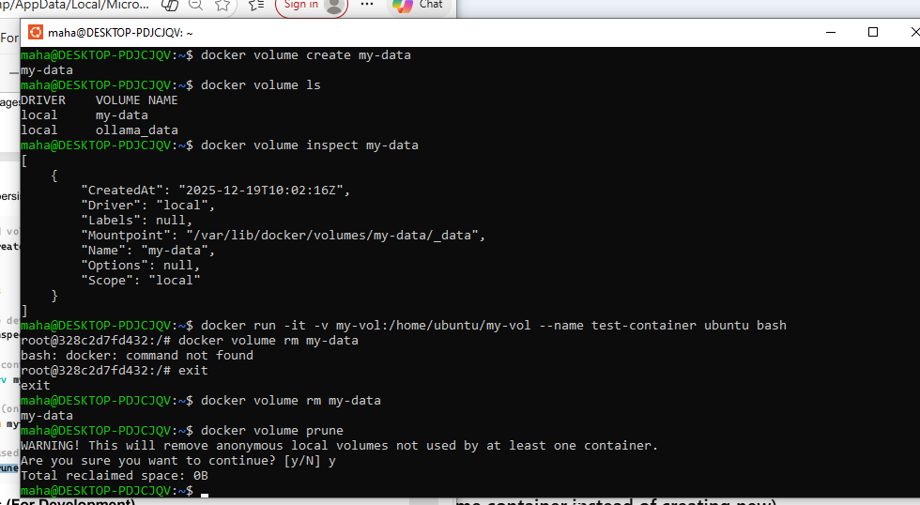
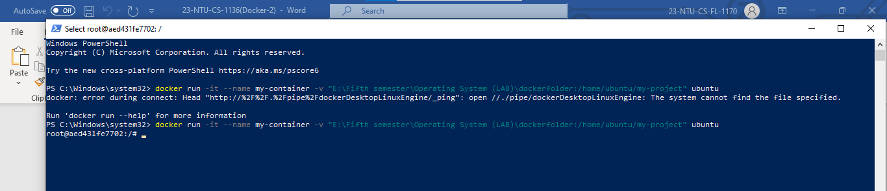

2. Bind Mounts (For Development)
What: Mount a host directory directly into container
Where: You specify exact host path
When: Development (live code changes), config files
#
M
ount

with

ab
solute

p
a
th
do
c
ker

run

-
it
-
v
/
home
/
user
/
my
a
pp
:
/
home
/
u
b
untu

u
b
untu
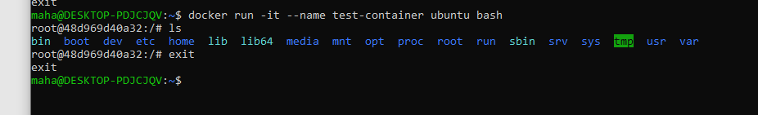

Volume Management Best Practices When to Use Which Type?
Storage Type | Use Case | Example
Named Volume | Production data, databases | PostgreSQL, MongoDB data
Bind Mount | Development, config files | Live code editing, nginx config

Part 2: Building Custom Images with Dockerfile
Why This Matters:
Now that you know how to use existing images, let’s create your own! This is where Docker becomes truly powerful - you can package your applications with all their dependencies.

Why Do We Need Custom Images?
So far, we’ve used pre-built images from Docker Hub:
do
c
ker

run

nginx
do
c
ker

run

node
:
18
do
c
ker

run

postgres
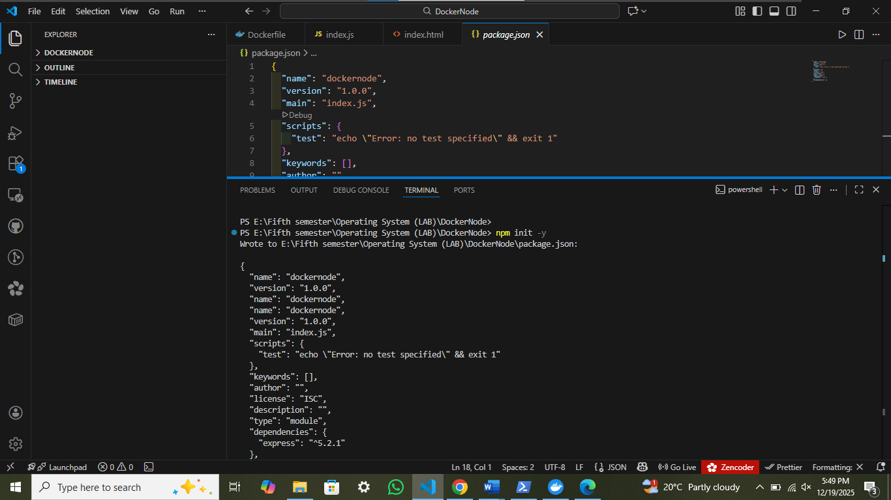
These are great, but they’re generic. What if you want to:
Add your own application code?
Install specific packages?
Configure custom settings?
Create a reproducible environment for your project?
Answer: Build your own images with Dockerfile!

Your First Dockerfile
Let’s create a simple custom image step by step!

Step 1: Create a Project Directory
c
d

~
mkdir

my
-
first
-
do
c
ker
-
a
pp
c
d

my
-
first
-
do
c
ker
-
a
pp

Step 2: Create a Simple Node.js Server
First of all Install
express
in your working working directory using
node
.
import

express

from

'
express
'
c
onst

a
pp

=

express
(
)
a
pp
.
get
(
'/'
,
(
request
,
response
)
=
>
{
response
.
send
(
'
H
ello

from

N
ode
'
)
}
)
a
pp
.
listen
(
3000
)
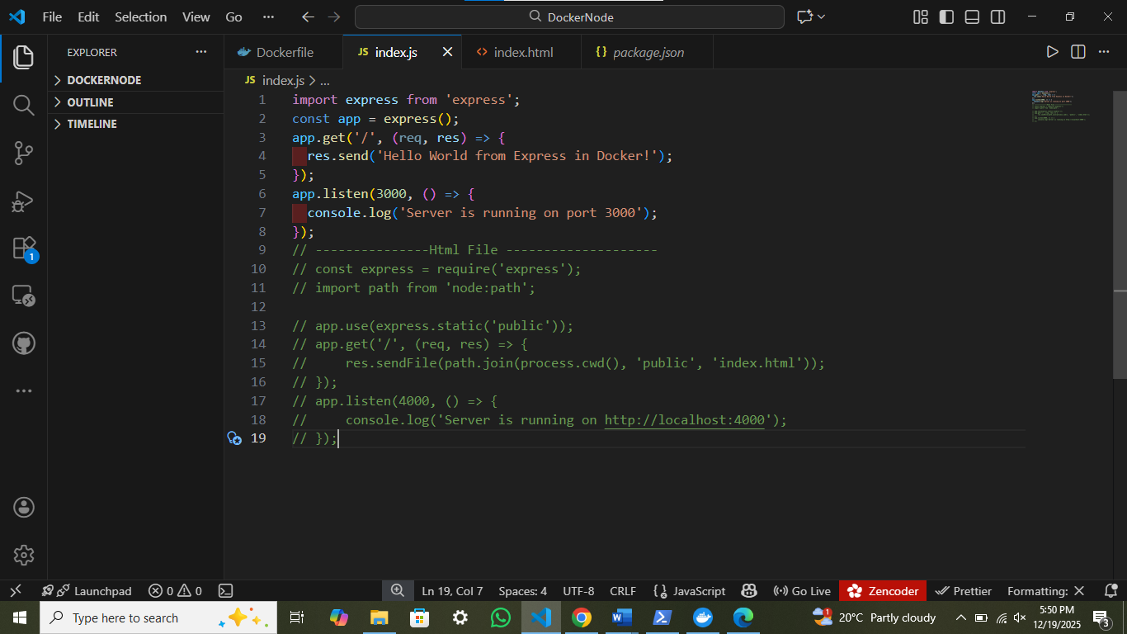
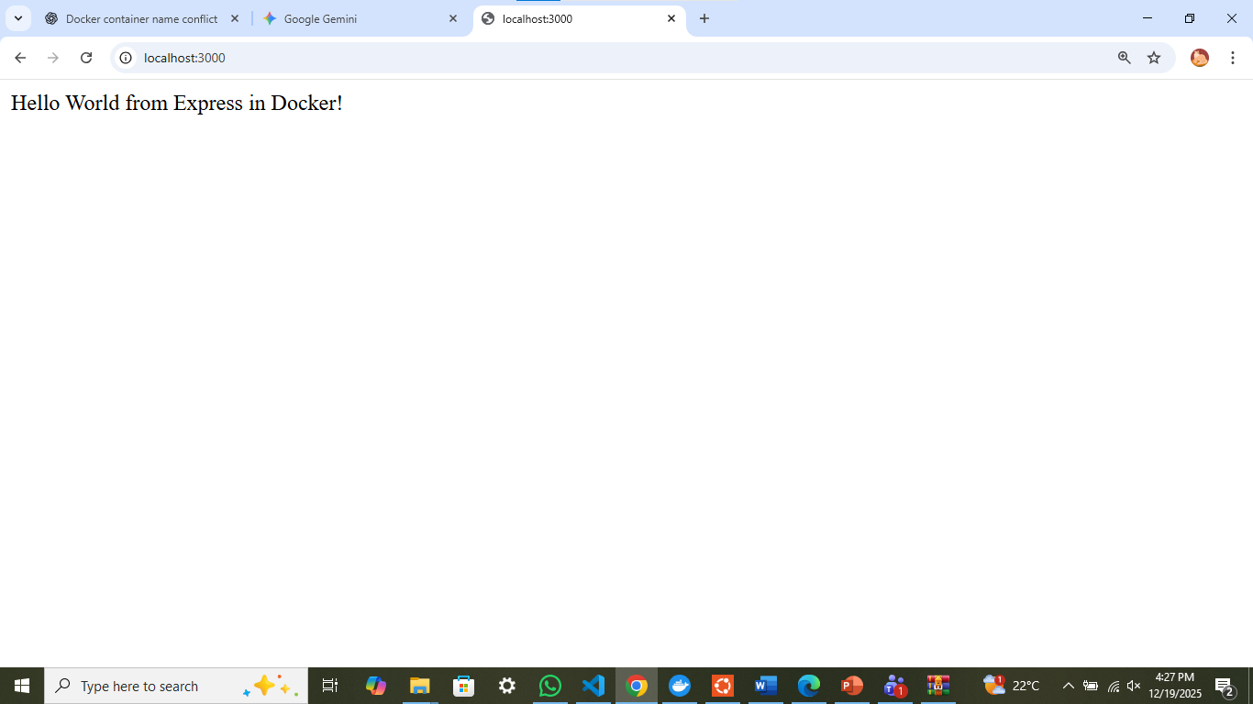

Class Task

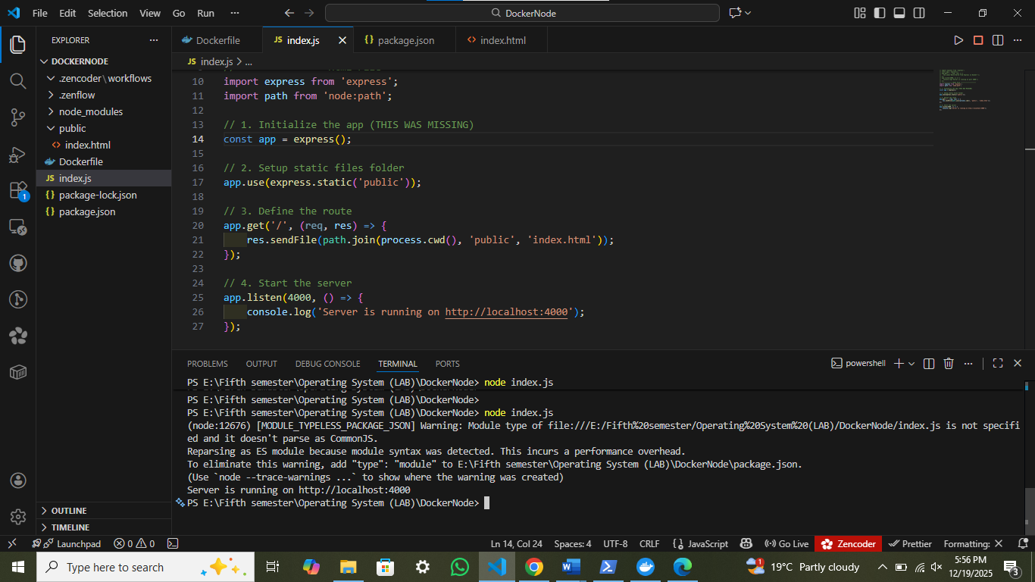
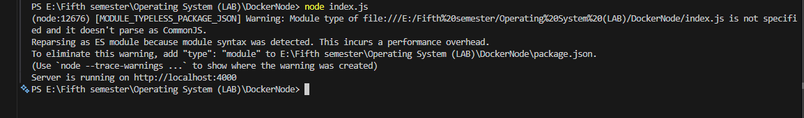

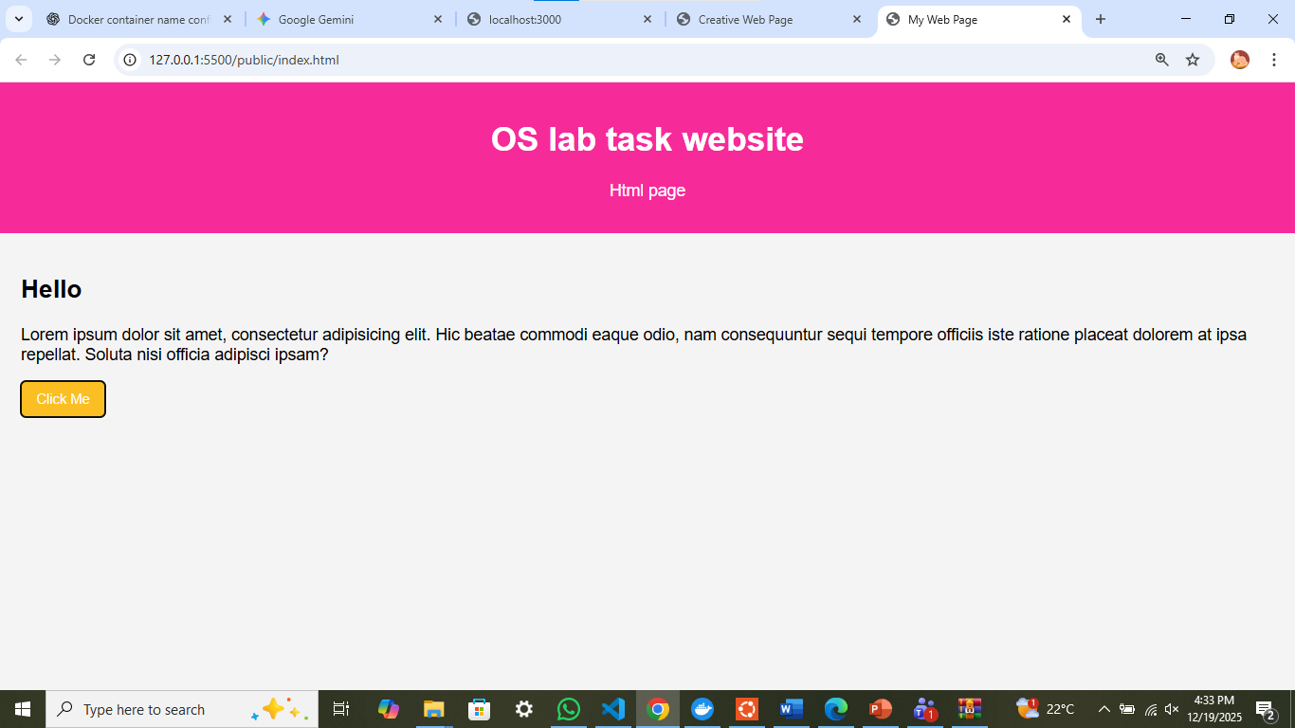

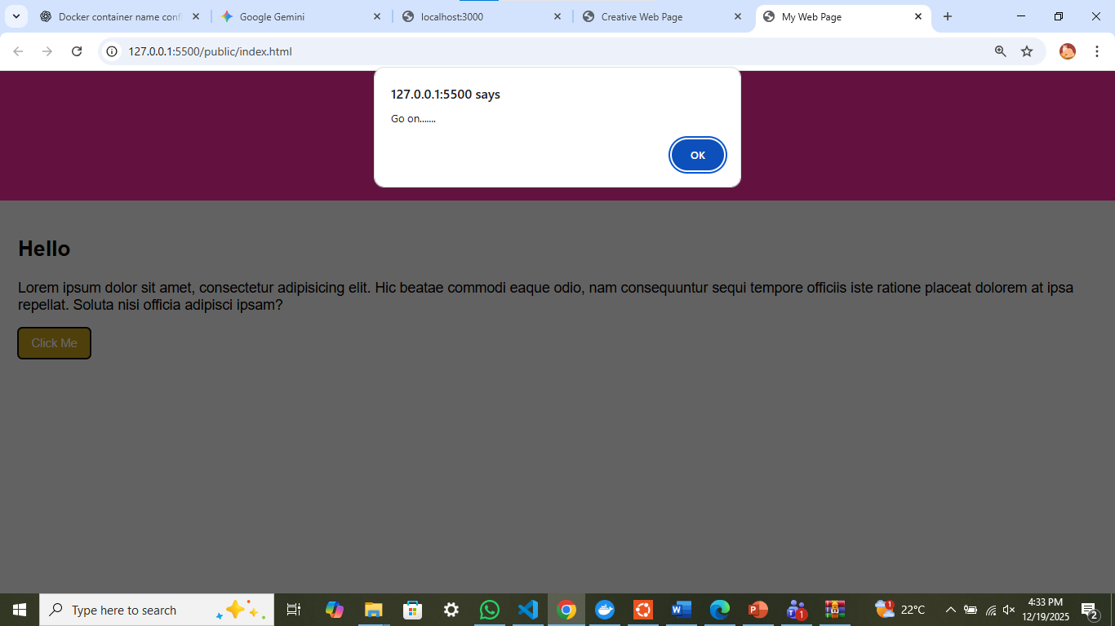

Step 3: Create Your First Dockerfile
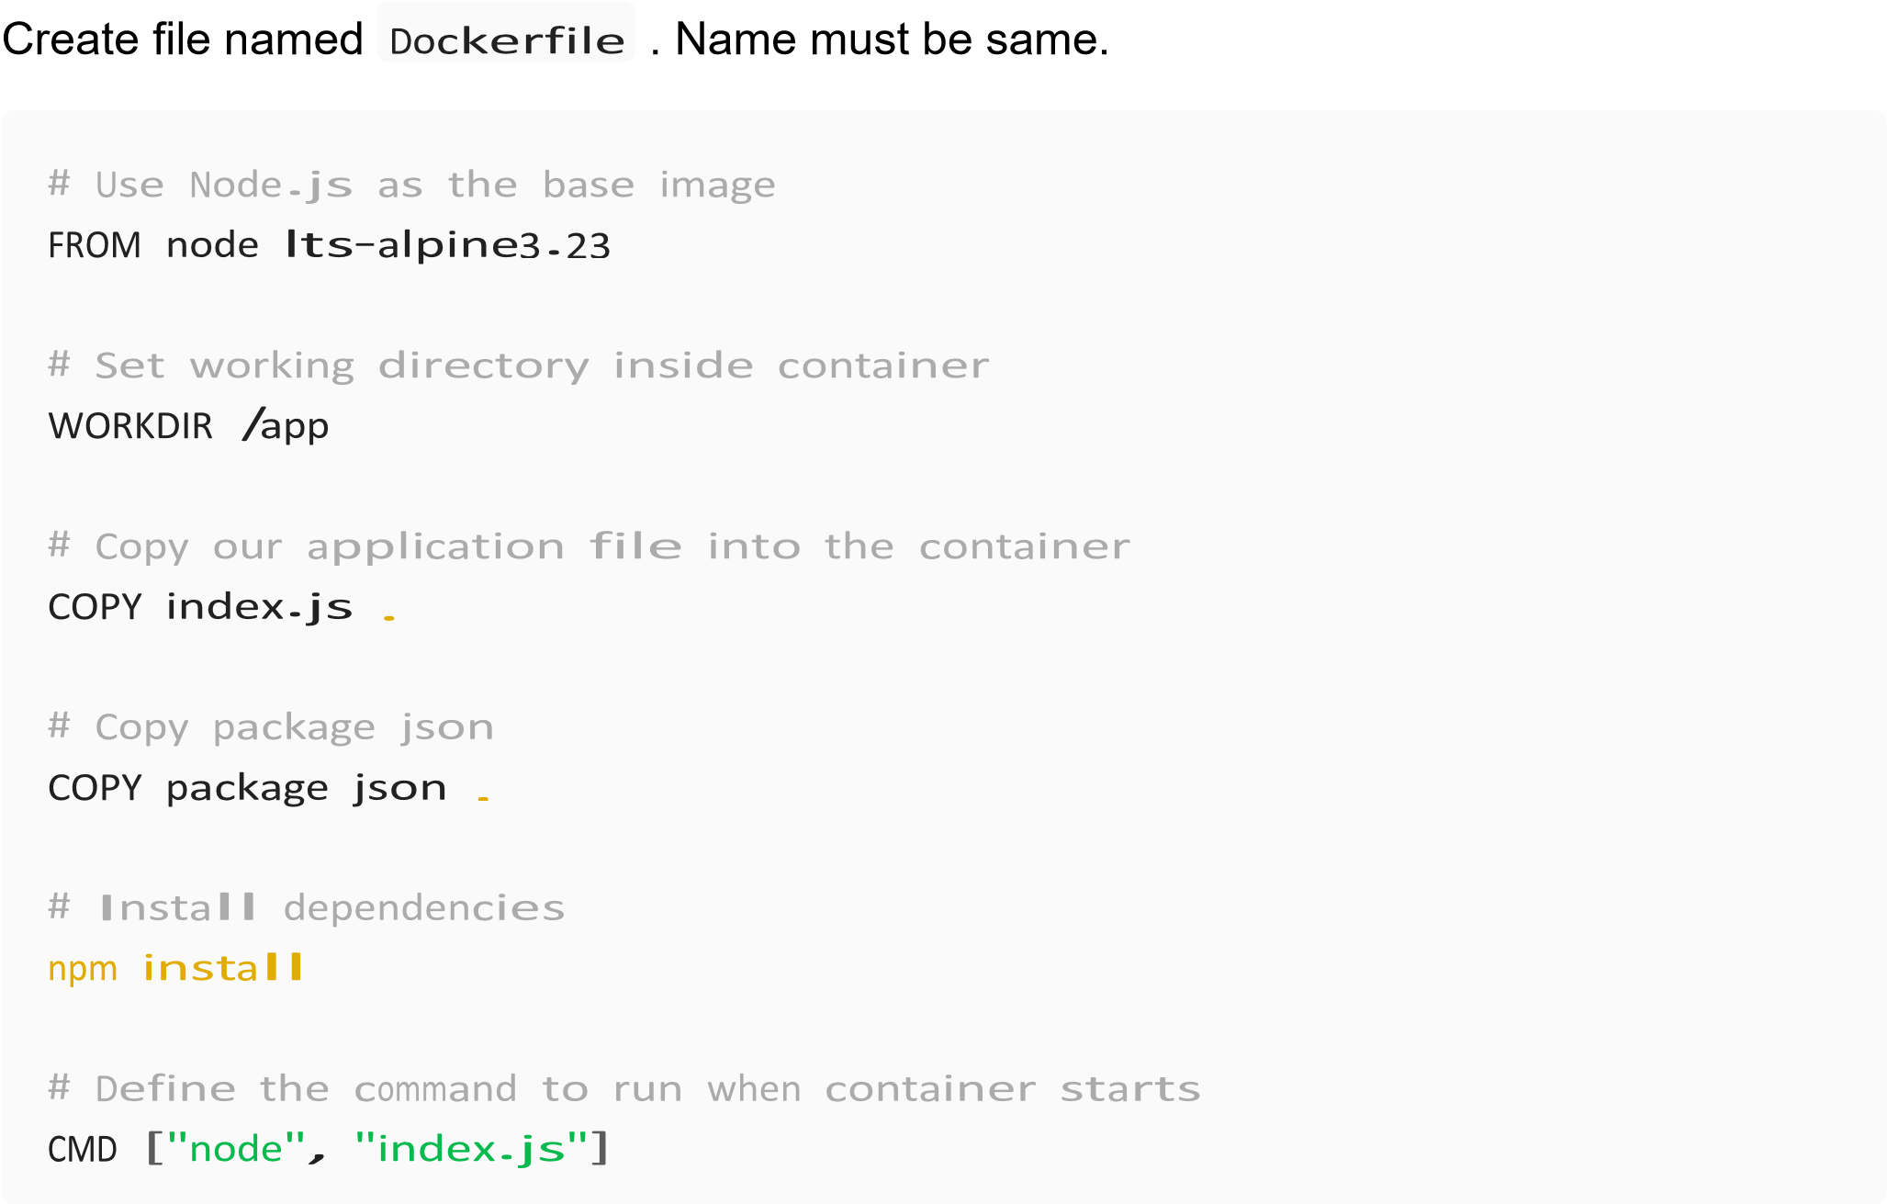
Docker commands in Vs:
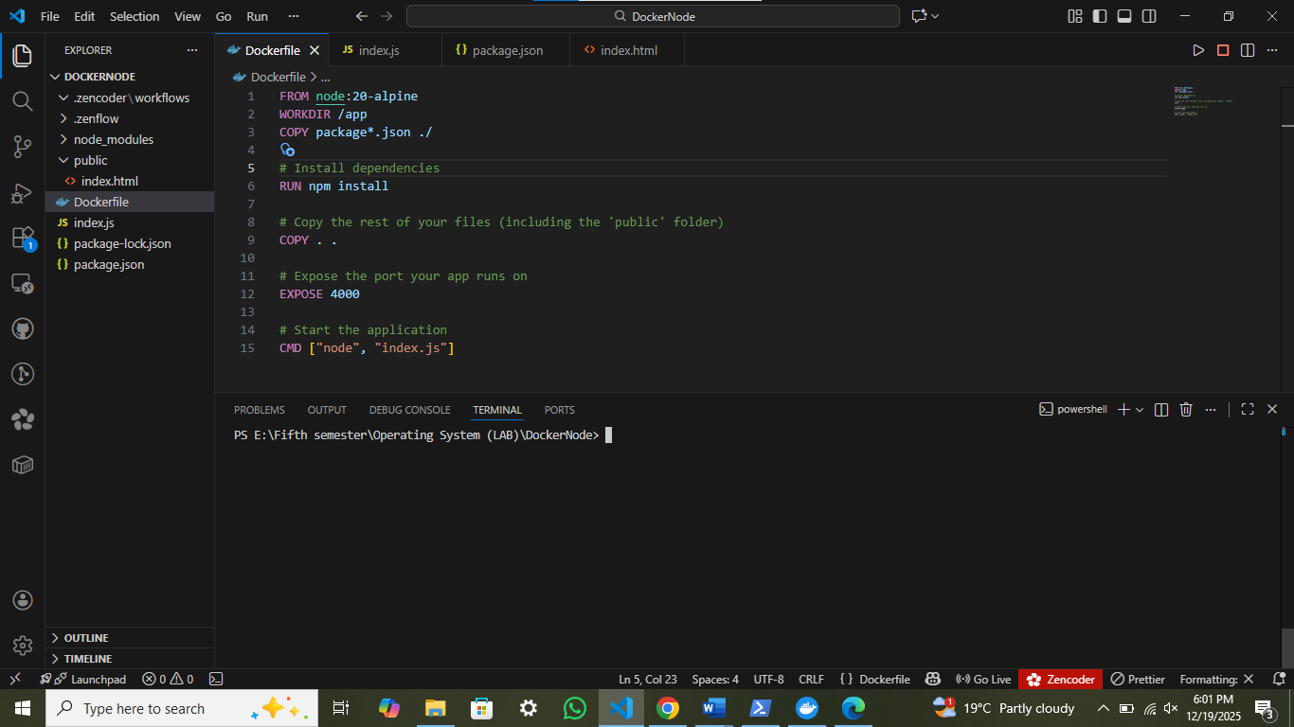
Run docker server:
